Downloading...
From: https://drive.google.com/uc?id=1VJaDVtDUtKQMmhRAqr3t-fgng899ZdRV
To: /content/Python Application Usage Log Data Set.xlsx
100%|██████████| 1.68M/1.68M [00:00<00:00, 12.2MB/s]
DEBUG:cmdstanpy:input tempfile: /tmp/tmpd65xp7pb/wthr8zn2.json
DEBUG:cmdstanpy:input tempfile: /tmp/tmpd65xp7pb/zbb4jayu.json
DEBUG:cmdstanpy:idx 0
DEBUG:cmdstanpy:running CmdStan, num_threads: None
DEBUG:cmdstanpy:CmdStan args: ['/usr/local/lib/python3.12/dist-packages/prophet/stan_model/prophet_model.bin', 'random', 'seed=5823', 'data', 'file=/tmp/tmpd65xp7pb/wthr8zn2.json', 'init=/tmp/tmpd65xp7pb/zbb4jayu.json', 'output', 'file=/tmp/tmpd65xp7pb/prophet_model8df8tw9q/prophet_model-20251025111630.csv', 'method=optimize', 'algorithm=lbfgs', 'iter=10000']
11:16:30 - cmdstanpy - INFO - Chain [1] start processing
INFO:cmdstanpy:Chain [1] start processing
11:16:40 - cmdstanpy - INFO - Chain [1] done processing
INFO:cmdstanpy:Chain [1] done processing
DEBUG:cmdstanpy:input tempfile: /tmp/tmpd65xp7pb/fi2pn9g5.json
DEBUG:cmdstanpy:input tempfile: /tmp/tmpd65xp7pb/jzbgdmze.json
DEBUG:cmdstanpy:idx 0
DEBUG:cmdstanpy:running CmdStan, num_threads: None
DEBUG:cmdstanpy:CmdStan args: ['/usr/local/lib/python3.12/dist-packages/prophet/stan_model/prophet_model.bin', 'random', 'seed=35666', 'data', 'file=/tmp/tmpd65xp7pb/fi2pn9g5.json', 'init=/tmp/tmpd65xp7pb/jzbgdmze.json', 'output', 'file=/tmp/tmpd65xp7pb/prophet_model2mapz6mr/prophet_model-20251025111641.csv', 'method=optimize', 'algorithm=lbfgs', 'iter=10000']
11:16:41 - cmdstanpy - INFO - Chain [1] start processing
INFO:cmdstanpy:Chain [1] start processing
11:16:48 - cmdstanpy - INFO - Chain [1] done processing
INFO:cmdstanpy:Chain [1] done processing
DEBUG:cmdstanpy:input tempfile: /tmp/tmpd65xp7pb/ik96jg1y.json
DEBUG:cmdstanpy:input tempfile: /tmp/tmpd65xp7pb/puh4ds70.json
DEBUG:cmdstanpy:idx 0
DEBUG:cmdstanpy:running CmdStan, num_threads: None
DEBUG:cmdstanpy:CmdStan args: ['/usr/local/lib/python3.12/dist-packages/prophet/stan_model/prophet_model.bin', 'random', 'seed=10347', 'data', 'file=/tmp/tmpd65xp7pb/ik96jg1y.json', 'init=/tmp/tmpd65xp7pb/puh4ds70.json', 'output', 'file=/tmp/tmpd65xp7pb/prophet_modelbr31g184/prophet_model-20251025111649.csv', 'method=optimize', 'algorithm=lbfgs', 'iter=10000']
11:16:49 - cmdstanpy - INFO - Chain [1] start processing
INFO:cmdstanpy:Chain [1] start processing
11:16:58 - cmdstanpy - INFO - Chain [1] done processing
INFO:cmdstanpy:Chain [1] done processing
DEBUG:cmdstanpy:input tempfile: /tmp/tmpd65xp7pb/13rwx9ie.json
DEBUG:cmdstanpy:input tempfile: /tmp/tmpd65xp7pb/fm6gpkw7.json
DEBUG:cmdstanpy:idx 0
DEBUG:cmdstanpy:running CmdStan, num_threads: None
DEBUG:cmdstanpy:CmdStan args: ['/usr/local/lib/python3.12/dist-packages/prophet/stan_model/prophet_model.bin', 'random', 'seed=15801', 'data', 'file=/tmp/tmpd65xp7pb/13rwx9ie.json', 'init=/tmp/tmpd65xp7pb/fm6gpkw7.json', 'output', 'file=/tmp/tmpd65xp7pb/prophet_modeleapyulpp/prophet_model-20251025111659.csv', 'method=optimize', 'algorithm=lbfgs', 'iter=10000']
11:16:59 - cmdstanpy - INFO - Chain [1] start processing
INFO:cmdstanpy:Chain [1] start processing
11:17:06 - cmdstanpy - INFO - Chain [1] done processing
INFO:cmdstanpy:Chain [1] done processing
DEBUG:cmdstanpy:input tempfile: /tmp/tmpd65xp7pb/g9a9i6lk.json
DEBUG:cmdstanpy:input tempfile: /tmp/tmpd65xp7pb/2xzo7cyh.json
DEBUG:cmdstanpy:idx 0
DEBUG:cmdstanpy:running CmdStan, num_threads: None
DEBUG:cmdstanpy:CmdStan args: ['/usr/local/lib/python3.12/dist-packages/prophet/stan_model/prophet_model.bin', 'random', 'seed=25492', 'data', 'file=/tmp/tmpd65xp7pb/g9a9i6lk.json', 'init=/tmp/tmpd65xp7pb/2xzo7cyh.json', 'output', 'file=/tmp/tmpd65xp7pb/prophet_model8wm9kb6z/prophet_model-20251025111707.csv', 'method=optimize', 'algorithm=lbfgs', 'iter=10000']
11:17:07 - cmdstanpy - INFO - Chain [1] start processing
INFO:cmdstanpy:Chain [1] start processing
11:17:13 - cmdstanpy - INFO - Chain [1] done processing
INFO:cmdstanpy:Chain [1] done processing
DEBUG:cmdstanpy:input tempfile: /tmp/tmpd65xp7pb/sjtuu4_e.json
DEBUG:cmdstanpy:input tempfile: /tmp/tmpd65xp7pb/7e2tcneh.json
DEBUG:cmdstanpy:idx 0
DEBUG:cmdstanpy:running CmdStan, num_threads: None
DEBUG:cmdstanpy:CmdStan args: ['/usr/local/lib/python3.12/dist-packages/prophet/stan_model/prophet_model.bin', 'random', 'seed=78408', 'data', 'file=/tmp/tmpd65xp7pb/sjtuu4_e.json', 'init=/tmp/tmpd65xp7pb/7e2tcneh.json', 'output', 'file=/tmp/tmpd65xp7pb/prophet_modelmpdlyg9w/prophet_model-20251025111714.csv', 'method=optimize', 'algorithm=lbfgs', 'iter=10000']
11:17:14 - cmdstanpy - INFO - Chain [1] start processing
INFO:cmdstanpy:Chain [1] start processing
11:17:17 - cmdstanpy - INFO - Chain [1] done processing
INFO:cmdstanpy:Chain [1] done processing
DEBUG:cmdstanpy:input tempfile: /tmp/tmpd65xp7pb/f9scht8q.json
DEBUG:cmdstanpy:input tempfile: /tmp/tmpd65xp7pb/oj4b6fwc.json
DEBUG:cmdstanpy:idx 0
DEBUG:cmdstanpy:running CmdStan, num_threads: None
DEBUG:cmdstanpy:CmdStan args: ['/usr/local/lib/python3.12/dist-packages/prophet/stan_model/prophet_model.bin', 'random', 'seed=43420', 'data', 'file=/tmp/tmpd65xp7pb/f9scht8q.json', 'init=/tmp/tmpd65xp7pb/oj4b6fwc.json', 'output', 'file=/tmp/tmpd65xp7pb/prophet_model4auwytkh/prophet_model-20251025111717.csv', 'method=optimize', 'algorithm=lbfgs', 'iter=10000']
11:17:17 - cmdstanpy - INFO - Chain [1] start processing
INFO:cmdstanpy:Chain [1] start processing
11:17:23 - cmdstanpy - INFO - Chain [1] done processing
INFO:cmdstanpy:Chain [1] done processing
DEBUG:cmdstanpy:input tempfile: /tmp/tmpd65xp7pb/ivojw_kr.json
DEBUG:cmdstanpy:input tempfile: /tmp/tmpd65xp7pb/ahg5g7pr.json
DEBUG:cmdstanpy:idx 0
DEBUG:cmdstanpy:running CmdStan, num_threads: None
DEBUG:cmdstanpy:CmdStan args: ['/usr/local/lib/python3.12/dist-packages/prophet/stan_model/prophet_model.bin', 'random', 'seed=15057', 'data', 'file=/tmp/tmpd65xp7pb/ivojw_kr.json', 'init=/tmp/tmpd65xp7pb/ahg5g7pr.json', 'output', 'file=/tmp/tmpd65xp7pb/prophet_model6bq5yay6/prophet_model-20251025111724.csv', 'method=optimize', 'algorithm=lbfgs', 'iter=10000']
11:17:24 - cmdstanpy - INFO - Chain [1] start processing
INFO:cmdstanpy:Chain [1] start processing
11:17:29 - cmdstanpy - INFO - Chain [1] done processing
INFO:cmdstanpy:Chain [1] done processing
DEBUG:cmdstanpy:input tempfile: /tmp/tmpd65xp7pb/wgp8huw4.json
DEBUG:cmdstanpy:input tempfile: /tmp/tmpd65xp7pb/dz06cz9a.json
DEBUG:cmdstanpy:idx 0
DEBUG:cmdstanpy:running CmdStan, num_threads: None
DEBUG:cmdstanpy:CmdStan args: ['/usr/local/lib/python3.12/dist-packages/prophet/stan_model/prophet_model.bin', 'random', 'seed=77151', 'data', 'file=/tmp/tmpd65xp7pb/wgp8huw4.json', 'init=/tmp/tmpd65xp7pb/dz06cz9a.json', 'output', 'file=/tmp/tmpd65xp7pb/prophet_model6sganlkm/prophet_model-20251025111729.csv', 'method=optimize', 'algorithm=lbfgs', 'iter=10000']
11:17:29 - cmdstanpy - INFO - Chain [1] start processing
INFO:cmdstanpy:Chain [1] start processing
11:17:33 - cmdstanpy - INFO - Chain [1] done processing
INFO:cmdstanpy:Chain [1] done processing
DEBUG:cmdstanpy:input tempfile: /tmp/tmpd65xp7pb/8j_n2hiz.json
DEBUG:cmdstanpy:input tempfile: /tmp/tmpd65xp7pb/bmjkv9fi.json
DEBUG:cmdstanpy:idx 0
DEBUG:cmdstanpy:running CmdStan, num_threads: None
DEBUG:cmdstanpy:CmdStan args: ['/usr/local/lib/python3.12/dist-packages/prophet/stan_model/prophet_model.bin', 'random', 'seed=90452', 'data', 'file=/tmp/tmpd65xp7pb/8j_n2hiz.json', 'init=/tmp/tmpd65xp7pb/bmjkv9fi.json', 'output', 'file=/tmp/tmpd65xp7pb/prophet_modeloj4uehv6/prophet_model-20251025111734.csv', 'method=optimize', 'algorithm=lbfgs', 'iter=10000']
11:17:34 - cmdstanpy - INFO - Chain [1] start processing
INFO:cmdstanpy:Chain [1] start processing
11:17:39 - cmdstanpy - INFO - Chain [1] done processing
INFO:cmdstanpy:Chain [1] done processing
DEBUG:cmdstanpy:input tempfile: /tmp/tmpd65xp7pb/33ymx7c1.json
DEBUG:cmdstanpy:input tempfile: /tmp/tmpd65xp7pb/3cinqxmz.json
DEBUG:cmdstanpy:idx 0
DEBUG:cmdstanpy:running CmdStan, num_threads: None
DEBUG:cmdstanpy:CmdStan args: ['/usr/local/lib/python3.12/dist-packages/prophet/stan_model/prophet_model.bin', 'random', 'seed=48588', 'data', 'file=/tmp/tmpd65xp7pb/33ymx7c1.json', 'init=/tmp/tmpd65xp7pb/3cinqxmz.json', 'output', 'file=/tmp/tmpd65xp7pb/prophet_model3b3a5w17/prophet_model-20251025111740.csv', 'method=optimize', 'algorithm=lbfgs', 'iter=10000']
11:17:40 - cmdstanpy - INFO - Chain [1] start processing
INFO:cmdstanpy:Chain [1] start processing
11:17:42 - cmdstanpy - INFO - Chain [1] done processing
INFO:cmdstanpy:Chain [1] done processing
DEBUG:cmdstanpy:input tempfile: /tmp/tmpd65xp7pb/3_tmhhz3.json
DEBUG:cmdstanpy:input tempfile: /tmp/tmpd65xp7pb/tik8izbt.json
DEBUG:cmdstanpy:idx 0
DEBUG:cmdstanpy:running CmdStan, num_threads: None
DEBUG:cmdstanpy:CmdStan args: ['/usr/local/lib/python3.12/dist-packages/prophet/stan_model/prophet_model.bin', 'random', 'seed=5832', 'data', 'file=/tmp/tmpd65xp7pb/3_tmhhz3.json', 'init=/tmp/tmpd65xp7pb/tik8izbt.json', 'output', 'file=/tmp/tmpd65xp7pb/prophet_modelczf0icme/prophet_model-20251025111743.csv', 'method=optimize', 'algorithm=lbfgs', 'iter=10000']
11:17:43 - cmdstanpy - INFO - Chain [1] start processing
INFO:cmdstanpy:Chain [1] start processing
11:17:47 - cmdstanpy - INFO - Chain [1] done processing
INFO:cmdstanpy:Chain [1] done processing
DEBUG:cmdstanpy:input tempfile: /tmp/tmpd65xp7pb/pup_p0_3.json
DEBUG:cmdstanpy:input tempfile: /tmp/tmpd65xp7pb/q5g_pfmw.json
DEBUG:cmdstanpy:idx 0
DEBUG:cmdstanpy:running CmdStan, num_threads: None
DEBUG:cmdstanpy:CmdStan args: ['/usr/local/lib/python3.12/dist-packages/prophet/stan_model/prophet_model.bin', 'random', 'seed=54851', 'data', 'file=/tmp/tmpd65xp7pb/pup_p0_3.json', 'init=/tmp/tmpd65xp7pb/q5g_pfmw.json', 'output', 'file=/tmp/tmpd65xp7pb/prophet_modelr5a7243w/prophet_model-20251025111748.csv', 'method=optimize', 'algorithm=lbfgs', 'iter=10000']
11:17:48 - cmdstanpy - INFO - Chain [1] start processing
INFO:cmdstanpy:Chain [1] start processing
11:17:51 - cmdstanpy - INFO - Chain [1] done processing
INFO:cmdstanpy:Chain [1] done processing
DEBUG:cmdstanpy:input tempfile: /tmp/tmpd65xp7pb/v0e6w_52.json
DEBUG:cmdstanpy:input tempfile: /tmp/tmpd65xp7pb/ykb2191z.json
DEBUG:cmdstanpy:idx 0
DEBUG:cmdstanpy:running CmdStan, num_threads: None
DEBUG:cmdstanpy:CmdStan args: ['/usr/local/lib/python3.12/dist-packages/prophet/stan_model/prophet_model.bin', 'random', 'seed=63768', 'data', 'file=/tmp/tmpd65xp7pb/v0e6w_52.json', 'init=/tmp/tmpd65xp7pb/ykb2191z.json', 'output', 'file=/tmp/tmpd65xp7pb/prophet_model8yuddtwi/prophet_model-20251025111752.csv', 'method=optimize', 'algorithm=lbfgs', 'iter=10000']
11:17:52 - cmdstanpy - INFO - Chain [1] start processing
INFO:cmdstanpy:Chain [1] start processing
11:17:57 - cmdstanpy - INFO - Chain [1] done processing
INFO:cmdstanpy:Chain [1] done processing
DEBUG:cmdstanpy:input tempfile: /tmp/tmpd65xp7pb/b6w46up4.json
DEBUG:cmdstanpy:input tempfile: /tmp/tmpd65xp7pb/bl73ygaq.json
DEBUG:cmdstanpy:idx 0
DEBUG:cmdstanpy:running CmdStan, num_threads: None
DEBUG:cmdstanpy:CmdStan args: ['/usr/local/lib/python3.12/dist-packages/prophet/stan_model/prophet_model.bin', 'random', 'seed=18861', 'data', 'file=/tmp/tmpd65xp7pb/b6w46up4.json', 'init=/tmp/tmpd65xp7pb/bl73ygaq.json', 'output', 'file=/tmp/tmpd65xp7pb/prophet_modelokre89jn/prophet_model-20251025111758.csv', 'method=optimize', 'algorithm=lbfgs', 'iter=10000']
11:17:58 - cmdstanpy - INFO - Chain [1] start processing
INFO:cmdstanpy:Chain [1] start processing
11:18:05 - cmdstanpy - INFO - Chain [1] done processing
INFO:cmdstanpy:Chain [1] done processing
DEBUG:cmdstanpy:input tempfile: /tmp/tmpd65xp7pb/p77ikruh.json
DEBUG:cmdstanpy:input tempfile: /tmp/tmpd65xp7pb/ss3bv2or.json
DEBUG:cmdstanpy:idx 0
DEBUG:cmdstanpy:running CmdStan, num_threads: None
DEBUG:cmdstanpy:CmdStan args: ['/usr/local/lib/python3.12/dist-packages/prophet/stan_model/prophet_model.bin', 'random', 'seed=64124', 'data', 'file=/tmp/tmpd65xp7pb/p77ikruh.json', 'init=/tmp/tmpd65xp7pb/ss3bv2or.json', 'output', 'file=/tmp/tmpd65xp7pb/prophet_modelh4mso2md/prophet_model-20251025111805.csv', 'method=optimize', 'algorithm=lbfgs', 'iter=10000']
11:18:05 - cmdstanpy - INFO - Chain [1] start processing
INFO:cmdstanpy:Chain [1] start processing
11:18:11 - cmdstanpy - INFO - Chain [1] done processing
INFO:cmdstanpy:Chain [1] done processing
DEBUG:cmdstanpy:input tempfile: /tmp/tmpd65xp7pb/mubvo1xz.json
DEBUG:cmdstanpy:input tempfile: /tmp/tmpd65xp7pb/_c07_fdl.json
DEBUG:cmdstanpy:idx 0
DEBUG:cmdstanpy:running CmdStan, num_threads: None
DEBUG:cmdstanpy:CmdStan args: ['/usr/local/lib/python3.12/dist-packages/prophet/stan_model/prophet_model.bin', 'random', 'seed=4832', 'data', 'file=/tmp/tmpd65xp7pb/mubvo1xz.json', 'init=/tmp/tmpd65xp7pb/_c07_fdl.json', 'output', 'file=/tmp/tmpd65xp7pb/prophet_modeln7og3a8q/prophet_model-20251025111812.csv', 'method=optimize', 'algorithm=lbfgs', 'iter=10000']
11:18:12 - cmdstanpy - INFO - Chain [1] start processing
INFO:cmdstanpy:Chain [1] start processing
11:18:17 - cmdstanpy - INFO - Chain [1] done processing
INFO:cmdstanpy:Chain [1] done processing
Top-2 Prophet cfgs: [{'changepoint_prior_scale': 1.0, 'seasonality_mode': 'multiplicative'}, {'changepoint_prior_scale': 0.8, 'seasonality_mode': 'multiplicative'}]
Best LSTM: {'units': 64, 'dropout': 0.2, 'window': 21} (val_loss=0.0365) | alpha=0.394 | beta=0.054
HOLDOUT (28d) — MAE: 192.66 | RMSE: 281.42 | MAPE: 6.35% | Accuracy: 93.65%
Prophet-ensemble HOLDOUT MAPE: 10.53% → ΔMAPE vs Hybrid: +4.19 pts

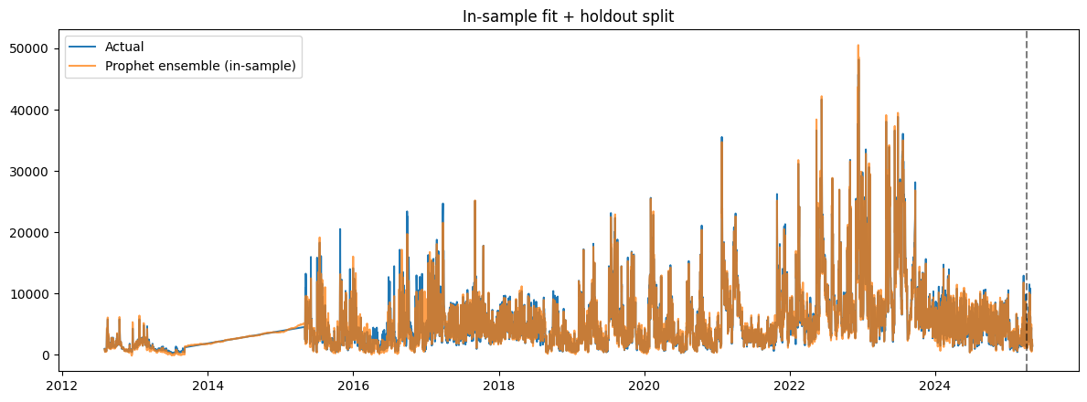
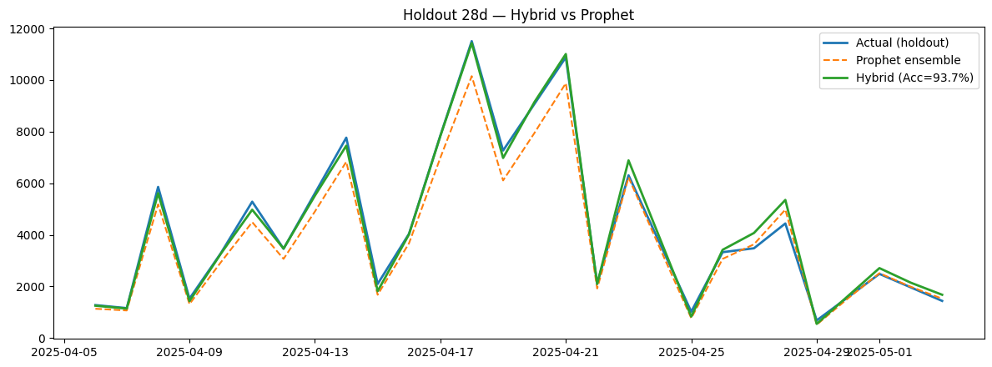
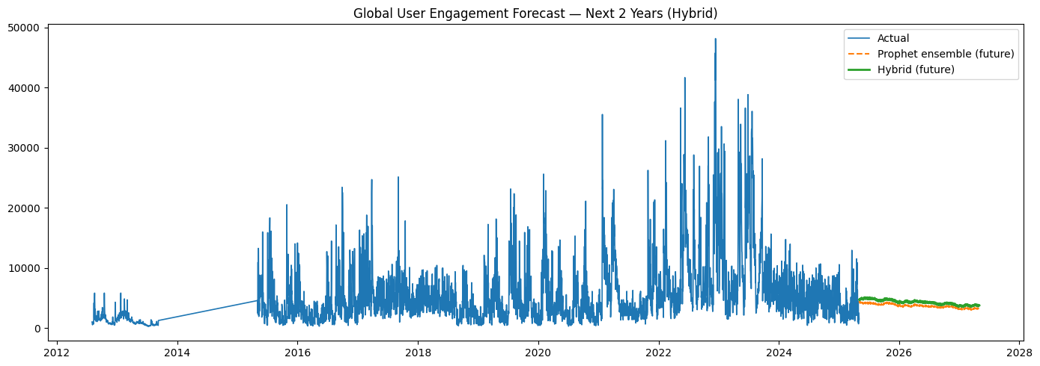
WARNING:absl:You are saving your model as an HDF5 file via `model.save()` or `keras.saving.save_model(model)`. This file format is considered legacy. We recommend using instead the native Keras format, e.g. `model.save('my_model.keras')` or `keras.saving.save_model(model, 'my_model.keras')`.

Artifacts: /content/hybrid_97acc_artifacts
- 2year_forecast.csv
- lstm_residual.h5
- metrics.json
- prophet_ensemble_cfgs.npy
- prophet_global.json
- x_scaler.npy
- y_scaler.npy

Checkpoints: /content/v3_ultrafast_ckpts
- lstm_best_win21.keras
- lstm_best_win28.keras
[None, None]

